Section 2
- Writa a module for a 2:1 mux
- Compose another module using (a) to have a 8:1 mux

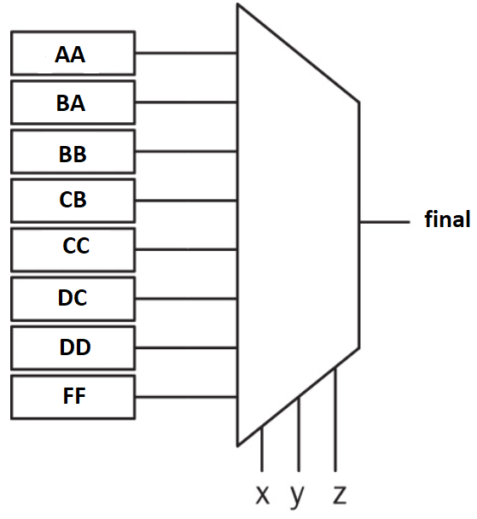
- LUT contains four hexadecimal constants: aa,ba,bb,cb,cc,dc,dd,ff
- Simulation part: Show your final grade at the output

Section 3
- Writa a module for a 2:1 mux
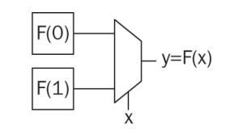
- Compose another module using (a) to have a 4:1 mux
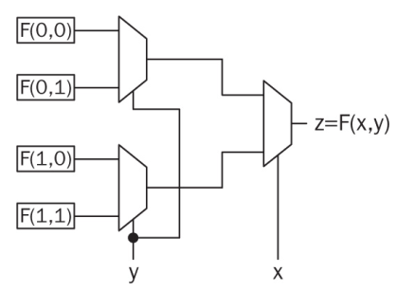
- Compose another module using (a) and (b) to have a 8:1 mux
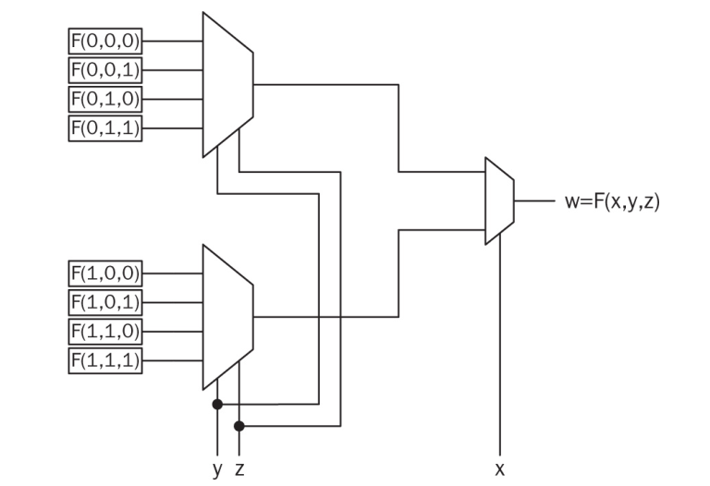

- LUT contains eight hexadecimal constants: aa,ba,bb,cb,cc,dc,dd,ff

- Simulation: Show your final grade at the output using appropriate x,y,z inputs

Section 1
- Writa a module for an 2:1 mux
- Compose another module using (a) to have a 4:1 mux
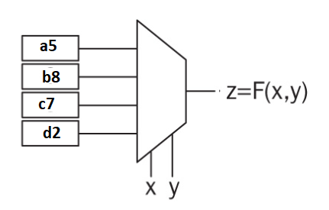
- LUT contains four hexadecimal constants: a5,b8,c7,d2
- Simulation part: Show c7 at the output

module sys(in1,out1,feed0,feed1);
output out1;
input in1;
input [7:0] feed0, feed1;
assign out1 = in1 ? feed1 : feed0;
endmodule

module fourM(in1,in2,out1,f1,f2,f3,f4);
output [7:0] out1;
input in1,in2;
input [7:0] f1, f2, f3, f4;
wire [7:0] fM, sM;

sys U1(in1,fM,f1,f2);
sys U2(in1,sM,f3,f4);
sys U3(in2,out1,fM,sM);
endmodule

module fourM_tb();
reg [7:0] f1,f2,f3,f4;
reg in1,in2;
wire [7:0] out1;

fourNM UUT(.in1(in1), .in2(in2), .out1(out1), .f1(f1), .f2(f2), .f3(f3), .f4(f4));

initial begin
in1 = 0;
in2 = 1;
f1 = 8’hA5;
f2 = 8’hB8;
f3 = 8’hC7;

end
endmodule

